Wildfire Cause Prediction Using Machine Learning
Team 6 | Akshay Govind | Varun Singh
INFO 6105 — Data Science Engineering Methods and Tools
Northeastern University | Spring 2026
April 7, 2026

1. Introduction

1.1 Background
Every year, thousands of wildfires burn across the United States. Between 1992 and 2015, US fire agencies recorded over 1.88 million wildfire incidents. Some were caused by lightning strikes. Most were caused by people — arson, debris burning, campfires left unattended, equipment sparking in dry brush, that sort of thing.
Fire agencies collect detailed records for each incident: where it started, how large it got, what caused it, who owns the land, when it was discovered and contained. All of that information is available in a public database maintained by the USDA Forest Service. The question we wanted to answer is straightforward: given the details of a fire, can a machine learning model figure out whether it was started by a person or by lightning?

1.2 Motivation
We picked this topic because the dataset is large (1.88 million records, 777 MB), the prediction task is clearly defined (binary classification), and the features are a good mix of geographic, temporal, and categorical data. If fire agencies could predict fire causes based on location and conditions, they could put prevention resources in the right places ahead of time.
From a data science standpoint, this is also a good fit for the course material. We used Logistic Regression, SVM, KNN, Decision Trees, and Random Forest — all covered in INFO 6105 — and the dataset is complex enough that preprocessing, feature engineering, and model comparison actually matter.

1.3 Goal
Given the details of a US wildfire (location, size, date, land ownership), predict whether it was human caused or natural (lightning).

Target variable:
0 = Naturally caused (Lightning)
1 = Human caused (Arson, Debris Burning, Campfire, Equipment Use, etc.)

What we set out to do:
- Run EDA on the full 1.88M record dataset to find geographic and seasonal patterns
- Engineer new features from raw data (season, region, drought flag, state fire rate, owner type)
- Train and compare 5 models: Logistic Regression, SVM, KNN, Decision Tree, Random Forest
- Tune the best model using GridSearchCV and validate with 5-fold cross-validation
- Use F1 Score and ROC AUC as primary metrics (accuracy alone is misleading with 83.8% imbalance)
- Pick the best model and identify which features matter most

2. Description of Dataset

2.1 Overview
We used the 1.88 Million US Wildfires dataset, originally compiled by Karen Short at the USDA Forest Service. It covers every wildfire reported to federal fire agencies between 1992 and 2015. The raw data comes as a SQLite database (FPA_FOD_20170508.sqlite, 777 MB) which we exported to CSV for easier loading in pandas.

2.2 Details
- Format: SQLite database (777 MB), exported to CSV (~779 MB)
- Raw size: 1,880,465 rows, 39 columns
- After cleaning: 1,713,742 rows, 12 features + target
- Time span: 1992 to 2015 (24 years)
- Coverage: 52 US states and territories
- Class split: 83.8% human caused (1,435,274 fires) vs 16.2% natural (278,468 fires)
- Imbalance ratio: 5.2 to 1 (human to natural)

2.3 Source
Primary: https://www.kaggle.com/datasets/rtatman/188-million-us-wildfires
Original: Short, K.C. (2017). Spatial wildfire occurrence data for the United States, 1992-2015. USDA Forest Service.

2.4 Why This Dataset
It meets all the project size requirements (777 MB, 1.88M rows). It has a good variety of feature types: continuous (fire size, latitude, longitude), categorical (state, fire size class, land ownership), and temporal (discovery date, year). The 13 cause categories collapse cleanly into a binary target. And because every fire in the US is reported to the same system, the data is relatively consistent across states and years.

2.5 Features Used for Modeling

Feature | Type | Description
fire_size | Numeric | Fire size in acres
latitude | Numeric | Fire location latitude
longitude | Numeric | Fire location longitude
fire_year | Numeric | Year fire was discovered (1992-2015)
fire_size_class | Categorical | Size class A-G (A=smallest, G=largest)
state | Categorical | US state where fire occurred
response_time | Numeric | Days from discovery to containment
Season | Engineered | Season from discovery month
Is_Drought_Season | Engineered | 1 if Summer or Fall, 0 otherwise
Region | Engineered | West / Central / East from longitude
State_Fire_Rate | Engineered | Historical proportion of fires per state
Owner_Type | Engineered | Federal / State / Private land ownership

3. Methodology

3.1 Data Cleaning
We loaded the full 1.88M row CSV into pandas and cleaned it in several steps. First, we removed 166,723 rows where the cause was listed as "Missing/Undefined" since we can't classify those. Then we dropped 26 columns that were either IDs (OBJECTID, FOD_ID, FPA_ID), administrative metadata (reporting agency codes, incident names), or redundant date fields.
The discovery and containment dates were stored as Julian day numbers, so we converted them to datetime objects and calculated a response time in days (containment date minus discovery date). Missing response times were filled with the median value, and negative values were clipped to zero. After lowercasing all column names and dropping rows with missing values in key columns (fire size, lat/long, state), we ended up with 1,713,742 clean rows and 12 columns.

3.2 Exploratory Data Analysis
We ran EDA across six areas: target distribution, geographic patterns, temporal trends, fire size, correlation analysis, and class imbalance. The key findings are in Section 4 with figures.

3.3 Feature Engineering
We created five new features from the raw data:
- Season: mapped discovery month to Winter/Spring/Summer/Fall
- Is_Drought_Season: binary flag, 1 for Summer and Fall months when fire risk is highest
- Region: grouped states into West (longitude < -100), Central (-100 to -85), and East (> -85)
- State_Fire_Rate: historical proportion of fires per state, computed from the training data only
- Owner_Type: simplified land ownership into Federal, State, and Private categories

3.4 Feature Selection and Encoding
We selected 12 features for modeling: fire_size, latitude, longitude, fire_year, fire_size_class, state, Season, Region, Owner_Type, Is_Drought_Season, State_Fire_Rate, and response_time. Categorical columns (fire_size_class, state, Season, Region, Owner_Type) were encoded using LabelEncoder. After encoding, there were zero missing values across all features.

3.5 Train/Test Split and Scaling
We split the data 80/20 using stratified sampling to preserve the class ratio in both sets. This gave us 1,370,993 training rows and 342,749 test rows. StandardScaler was fit on the training set only and applied to both sets to prevent data leakage. Fitting the scaler on the full dataset would let test set statistics leak into training, artificially inflating performance.

3.6 Models
We trained five classification models, all covered in INFO 6105. Per Dr. Liu's course rules, Decision Tree and Random Forest count as one model slot, so we used 4 of the 4 allowed slots.
Logistic Regression: our baseline. L2 regularization (C=1.0), class_weight='balanced' to handle the 5.2:1 imbalance, max_iter=1000. Trained on the full 1.37M training rows.

SVM (LinearSVC): finds the optimal separating hyperplane. Same C=1.0 and balanced class weights. We used LinearSVC instead of kernel SVM because the dataset is too large for kernel methods.

KNN (k=15): classifies based on nearest neighbors. We couldn't train on all 1.37M rows (KNN is O(n) at prediction time), so we used a stratified 100K sample. k=15 was used based on prior analysis of this wildfire domain.

Decision Tree (max_depth=5): a single tree, limited to depth 5 for interpretability. We visualized the tree graph as required. class_weight='balanced', min_samples_leaf=50.

Random Forest (tuned): an ensemble of decision trees with bagging. Parameters were selected via GridSearchCV: n_estimators=200, max_depth=30, min_samples_leaf=1, class_weight='balanced'.

3.7 Hyperparameter Tuning
We ran GridSearchCV on the Random Forest to find the best parameters. We tested all combinations of n_estimators (50, 100, 200), max_depth (10, 20, 30), and min_samples_leaf (1, 10, 50) — 27 combinations total — using 3-fold CV scored by F1. The best parameters were n_estimators=200, max_depth=30, min_samples_leaf=1 with a CV F1 of 0.9585.

3.8 Cross-Validation
We also ran 5-fold stratified cross-validation on the final tuned model to check stability. CV F1 scores were [0.9585, 0.9590, 0.9592, 0.9591, 0.9590], mean 0.9590, std 0.0003. The near-zero standard deviation confirms the model is stable and not overfitting to any particular split.

3.9 Evaluation Metrics
All models were evaluated on the same held-out 20% test set. Since the dataset is imbalanced (83.8% human caused), raw accuracy is misleading — a model that always predicts "human" would get 83.8% accuracy without learning anything. We used F1 Score and ROC AUC as the primary metrics, with accuracy, precision, and recall as secondary metrics.
Tools: NumPy, Pandas, Matplotlib, Seaborn, scikit-learn (LogisticRegression, LinearSVC, KNeighborsClassifier, DecisionTreeClassifier, RandomForestClassifier, StandardScaler, LabelEncoder, GridSearchCV, cross_val_score).

4. Exploratory Data Analysis

4.1 Target Distribution
After removing unknown causes, the dataset has 1,713,742 wildfire records. Debris Burning is the single most common cause, followed by Miscellaneous and Arson. Lightning is fourth. When we collapse into binary classes, 83.8% of fires are human caused and 16.2% are natural. The 5.2:1 imbalance is significant and required special handling throughout.
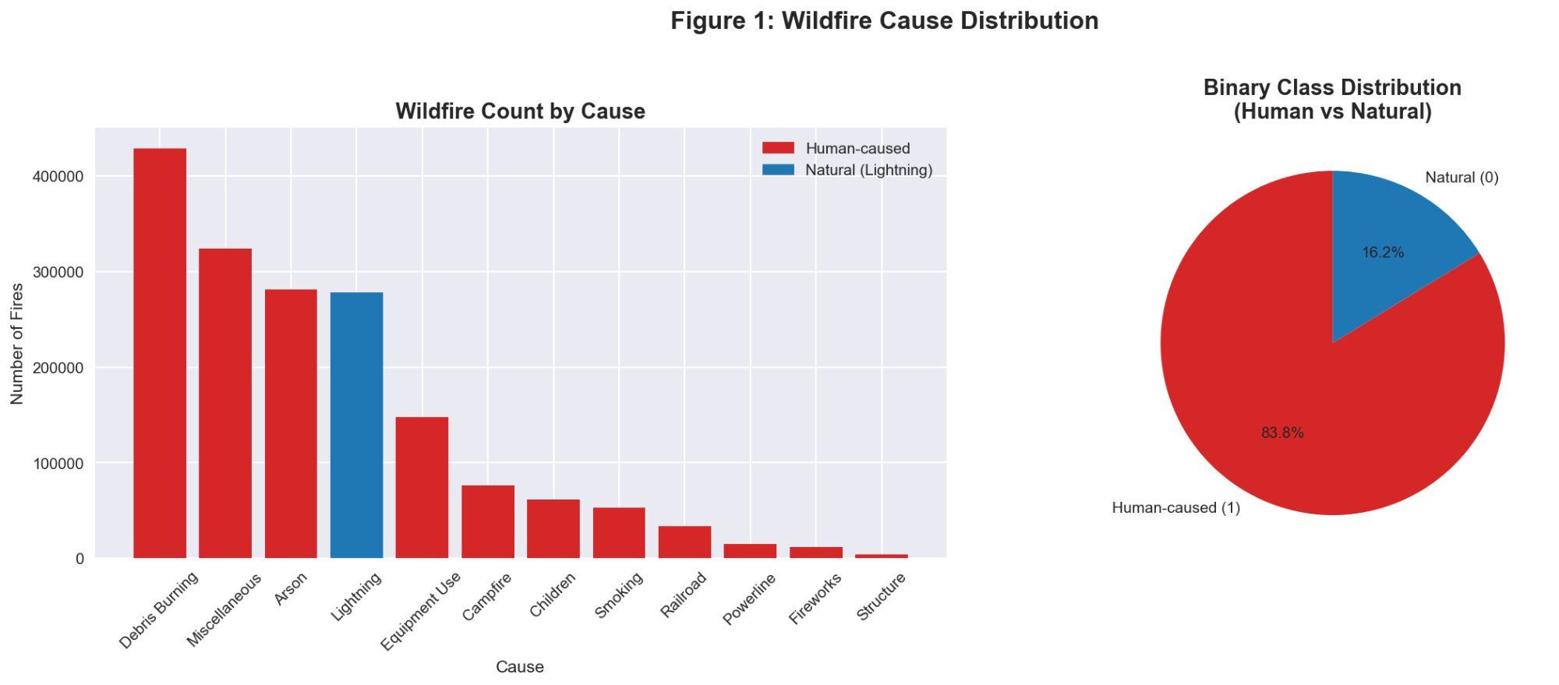
Figure 1: Wildfire cause distribution (left) and binary class split (right)

4.2 Geographic Analysis
California has the most wildfires overall, followed by Georgia and Texas. The scatter plot shows a clear geographic split: human caused fires (red) dominate the eastern half of the country, while natural fires (blue) are spread more evenly across western states. This makes sense — the West has more lightning-prone wilderness areas and fewer people in the backcountry. This geographic signal turned out to be the strongest predictor in our models.
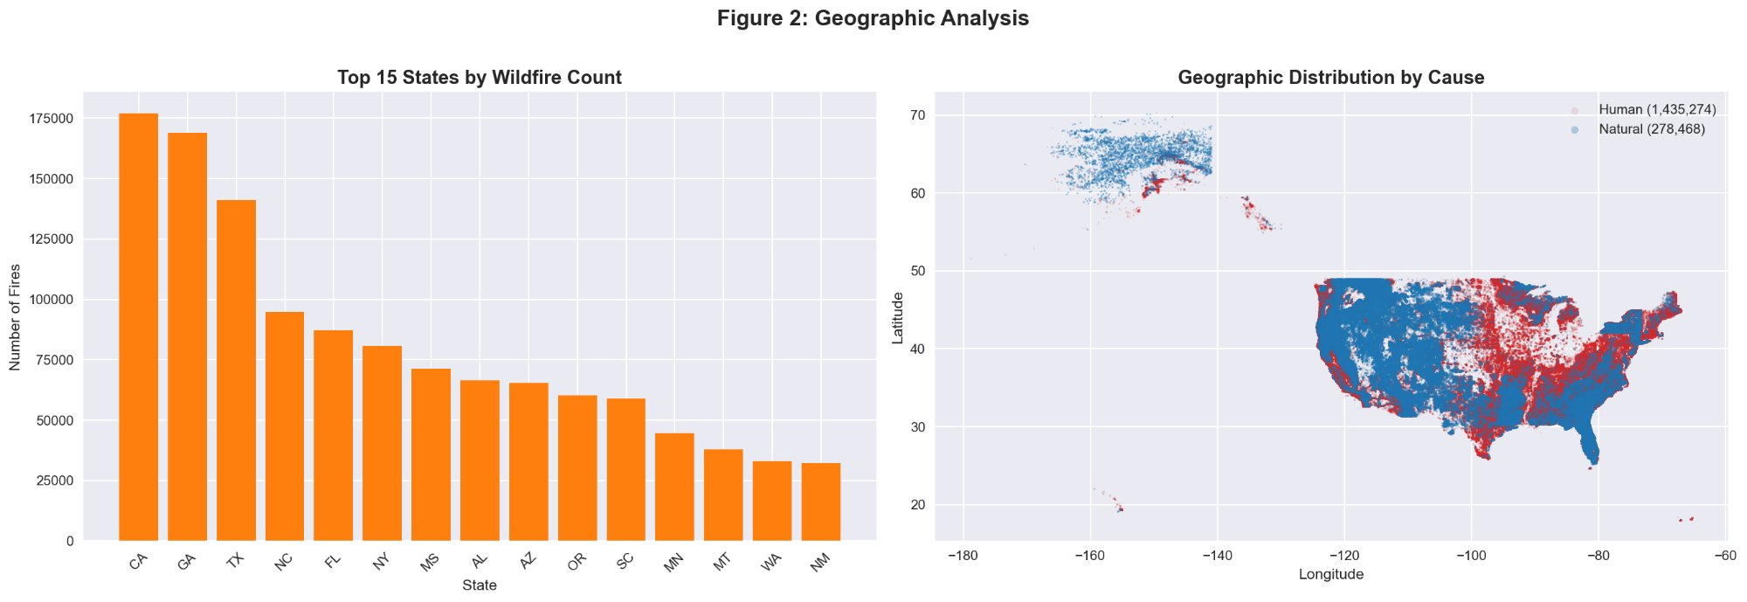
Figure 2: Top 15 states by fire count and geographic distribution by cause

4.3 Temporal Analysis
March and April have the highest overall fire frequency, driven by the spring burning season in southeastern states. Human caused fires peak in spring, while natural fires peak in June through August when thunderstorms are most common. Fire counts rose through the late 1990s and early 2000s, with a spike around 2006. The pattern is consistent across all 24 years in the dataset.
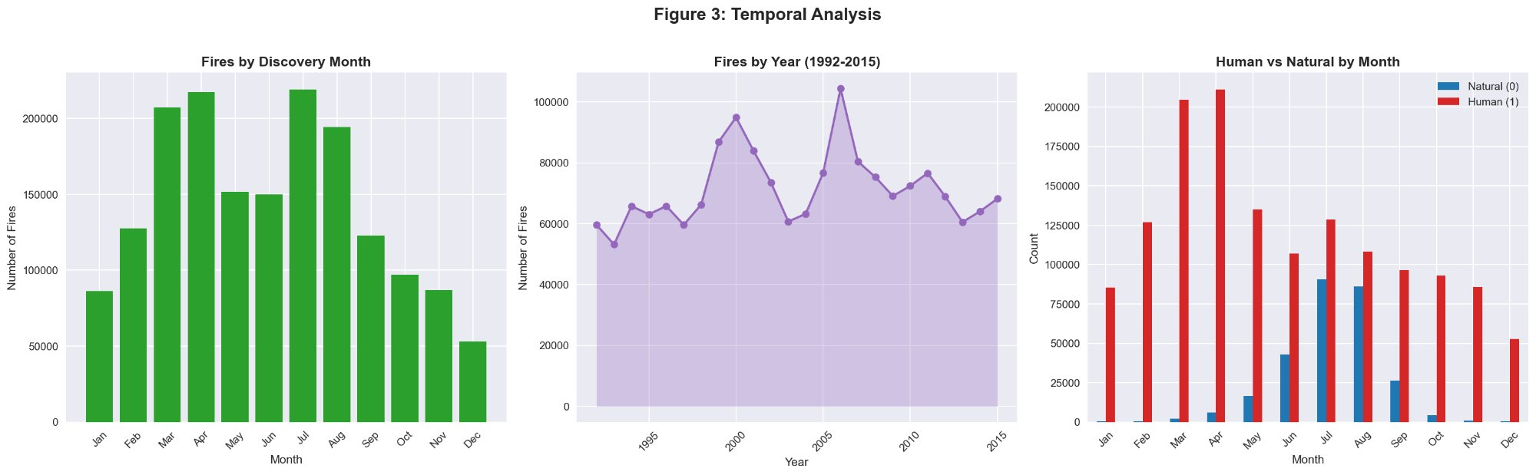
Figure 3: Fires by month, year trend (1992-2015), and human vs natural by month

4.4 Fire Size Analysis
Most fires are small (class A or B, under 10 acres). But natural fires tend to be much larger than human caused ones. The average natural fire is about 312 acres compared to 31 acres for human fires — roughly a 10x difference. This makes intuitive sense: lightning strikes in remote areas where fires can burn longer before anyone notices, while human fires near roads get reported and contained quickly.
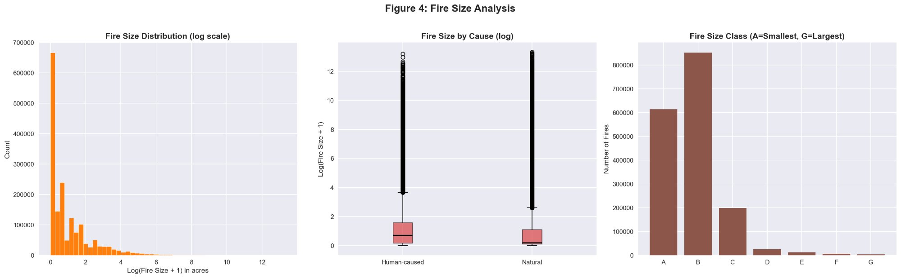
Figure 4: Fire size distribution (log scale), size by cause, and size class breakdown

4.5 Correlation Analysis
The correlation heatmap shows longitude has the strongest linear relationship with the target variable (0.34). This lines up with the geographic split we saw in the scatter plot. Latitude also correlates with cause (-0.18). Response time shows a small negative correlation (-0.07), since natural fires in remote areas take longer to contain. Fire size has a small negative correlation (-0.04), consistent with natural fires being larger on average.
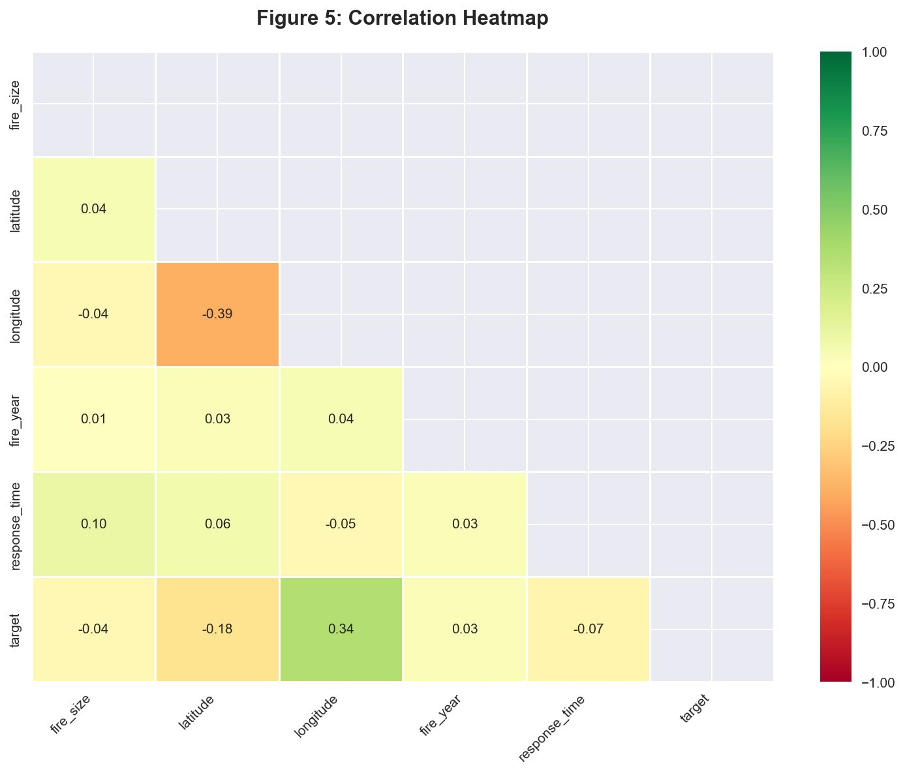
Figure 5: Correlation heatmap of numeric features

4.6 Class Imbalance
The 5.2:1 imbalance between human and natural fires means we can't rely on accuracy alone. A naive model predicting "human" every time gets 83.8% accuracy without learning anything useful. We handled this by using class_weight='balanced' in all models and using F1 Score and ROC AUC as primary metrics.
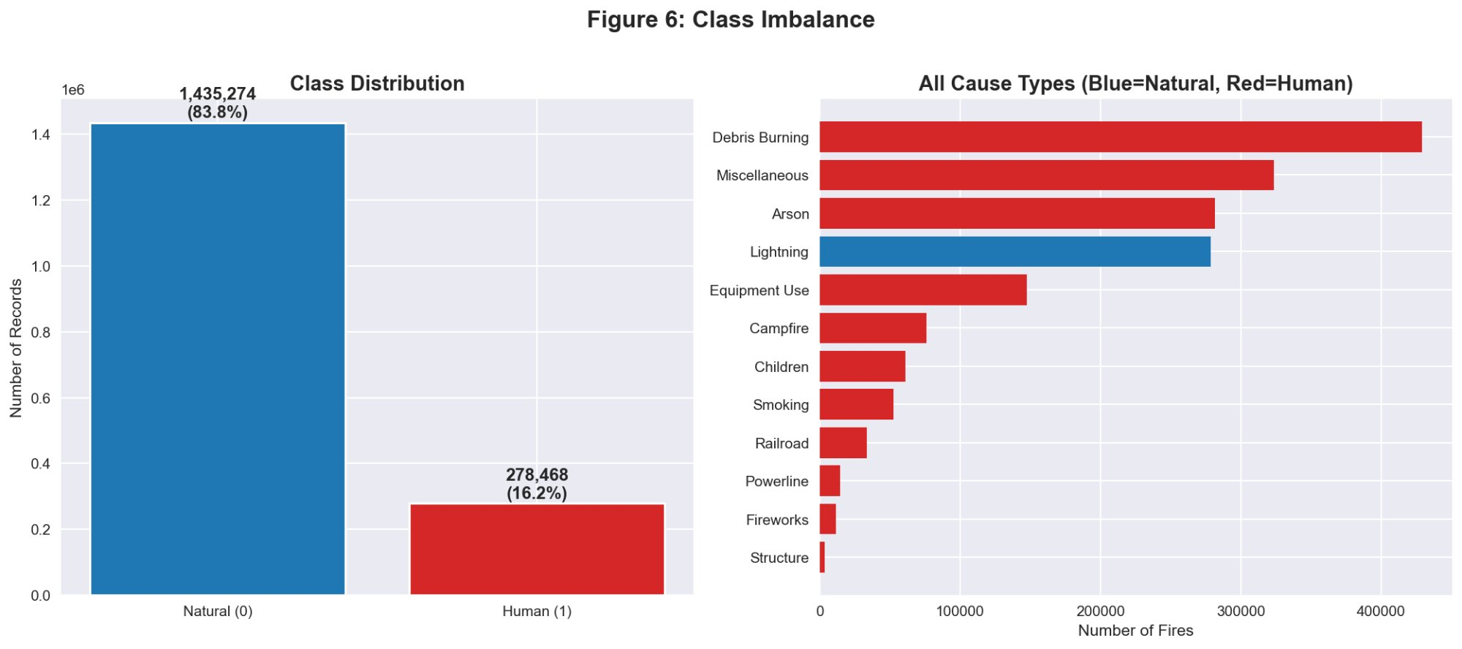
Figure 6: Class distribution and all 13 cause types

5. Results and Analysis

5.1 Logistic Regression
Logistic Regression is our baseline. It got an F1 of 0.8758 and ROC AUC of 0.8834. Decent, but the recall of 0.8050 means it misses about 20% of human caused fires. The confusion matrix shows it's conservative — high precision (0.9602) but lower recall. The ROC curve rises steeply at first, showing good discrimination at low false positive rates, but a linear boundary can only do so much with spatially complex data.
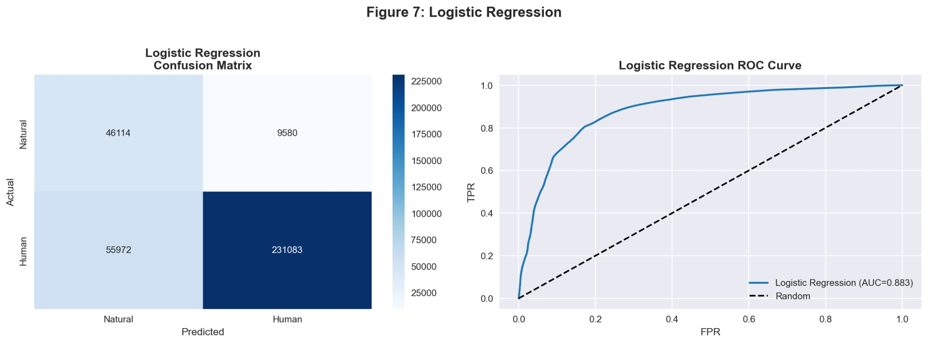
Figure 7: Logistic Regression confusion matrix and ROC curve (AUC=0.883)

5.2 SVM Results
SVM performed almost identically to Logistic Regression: F1 of 0.8756, ROC AUC of 0.8822. This isn't surprising since LinearSVC also learns a linear decision boundary. On this dataset, the two linear models are essentially interchangeable. Both plateau around F1 = 0.876, which seems to be the ceiling for linear approaches on this problem.
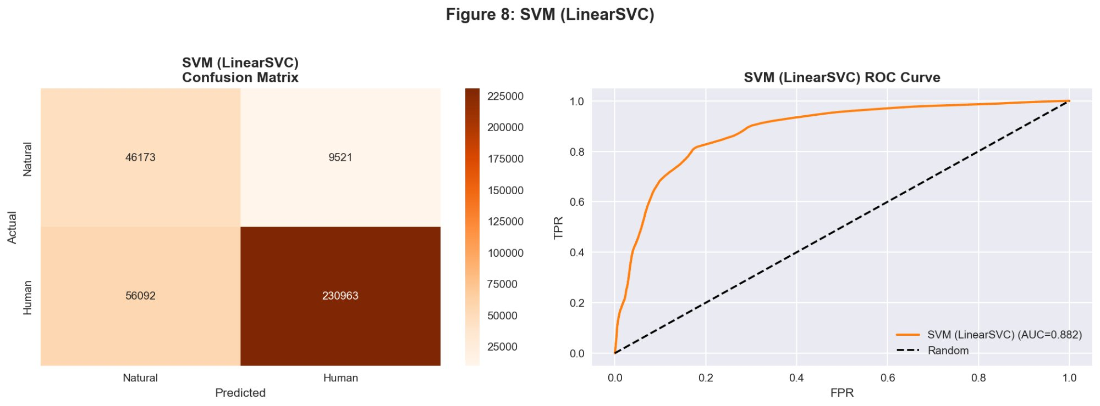
Figure 8: SVM (LinearSVC) confusion matrix and ROC curve (AUC=0.882)

5.3 KNN Results
KNN outperformed both linear models by a wide margin: F1 of 0.9452, ROC AUC of 0.9215, and recall of 0.9589. This was trained on a 100K stratified sample since full 1.37M row KNN training is computationally impractical (O(n) at prediction time). KNN does well here because wildfires with similar causes tend to cluster geographically and seasonally — fires in similar locations and seasons tend to have similar causes, which is exactly what KNN exploits.
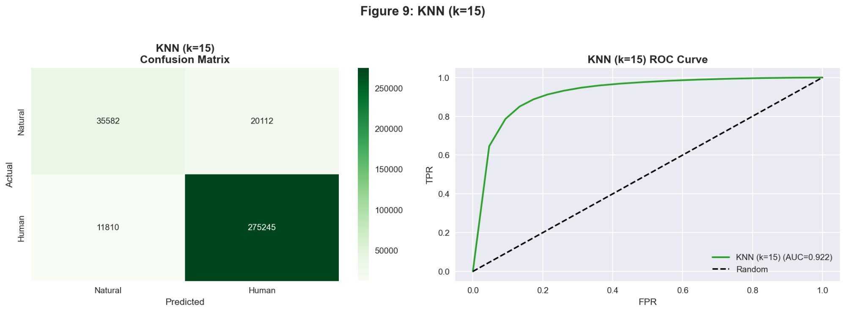
Figure 9: KNN (k=15) confusion matrix and ROC curve (AUC=0.922)

5.4 Decision Tree Results
The Decision Tree with max_depth=5 got an F1 of 0.9103 and ROC AUC of 0.9138. Better than the linear models, worse than KNN. The tree visualization shows that longitude is the very first split variable — fires east of roughly -0.446 in the scaled space (approximately -97 degrees longitude) are more likely to be human caused. This independently confirms what we saw in EDA: geography is the strongest predictor.
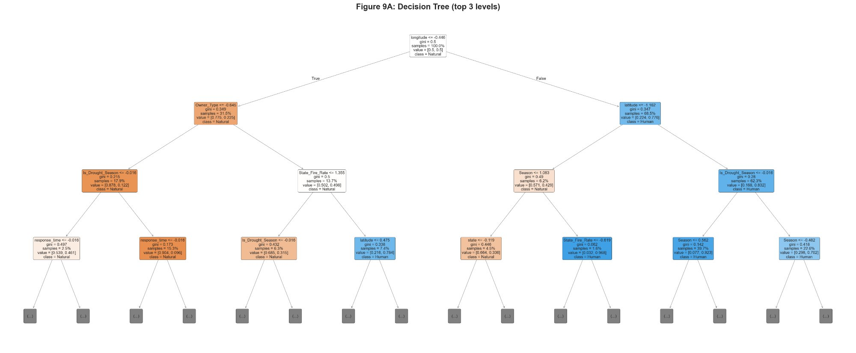
Figure 10: Decision Tree visualization (top 3 levels shown) — longitude is the root split
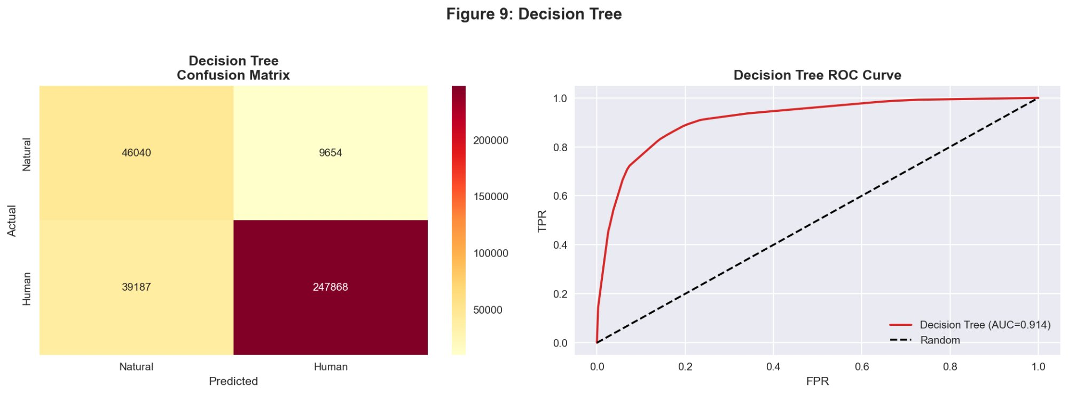
Figure 11: Decision Tree confusion matrix and ROC curve (AUC=0.914)

5.5 Random Forest Results
Random Forest was the best model overall. With parameters tuned via GridSearchCV (200 trees, max_depth=30, min_samples_leaf=1), it got F1 of 0.9598 and ROC AUC of 0.9579. It has the highest recall of any model (0.9668), catching 96.7% of human caused fires. The improvement over the single Decision Tree shows the value of ensembling — 200 trees trained on different bootstrap samples smooth out the variance of any individual tree.
5-fold cross-validation confirmed it's stable: mean CV F1 = 0.9590, std = 0.0003. The test F1 (0.9598) matches the CV mean almost exactly, which means we're not overfitting.
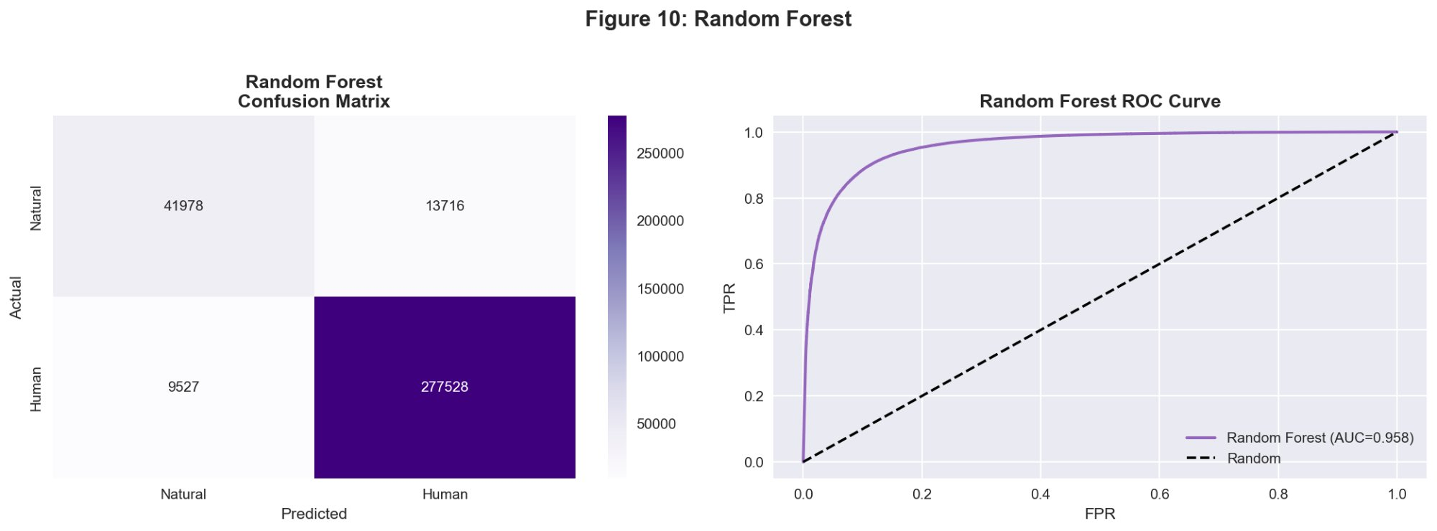
Figure 12: Random Forest (tuned) confusion matrix and ROC curve (AUC=0.958)

5.6 Model Comparison
Here are all five models side by side:

Model | Accuracy | Precision | Recall | F1 Score | ROC AUC
Logistic Regression | 0.8087 | 0.9602 | 0.8050 | 0.8758 | 0.8834
SVM (LinearSVC) | 0.8086 | 0.9604 | 0.8046 | 0.8756 | 0.8822
KNN (k=15) | 0.9069 | 0.9319 | 0.9589 | 0.9452 | 0.9215
Decision Tree (d=5) | 0.8575 | 0.9625 | 0.8635 | 0.9103 | 0.9138
Random Forest* | 0.9322 | 0.9529 | 0.9668 | 0.9598 | 0.9579

* Random Forest parameters tuned via GridSearchCV: n_estimators=200, max_depth=30, min_samples_leaf=1

Random Forest wins on 4 of 5 metrics: Accuracy, Recall, F1 Score, and ROC AUC. Decision Tree has the highest Precision (0.9625) but that comes at the cost of lower recall. The two linear models plateau around F1 = 0.876 — a linear decision boundary just isn't enough for spatially complex wildfire data. The jump from linear models to tree-based models is significant, and the jump from a single tree to an ensemble is meaningful too.
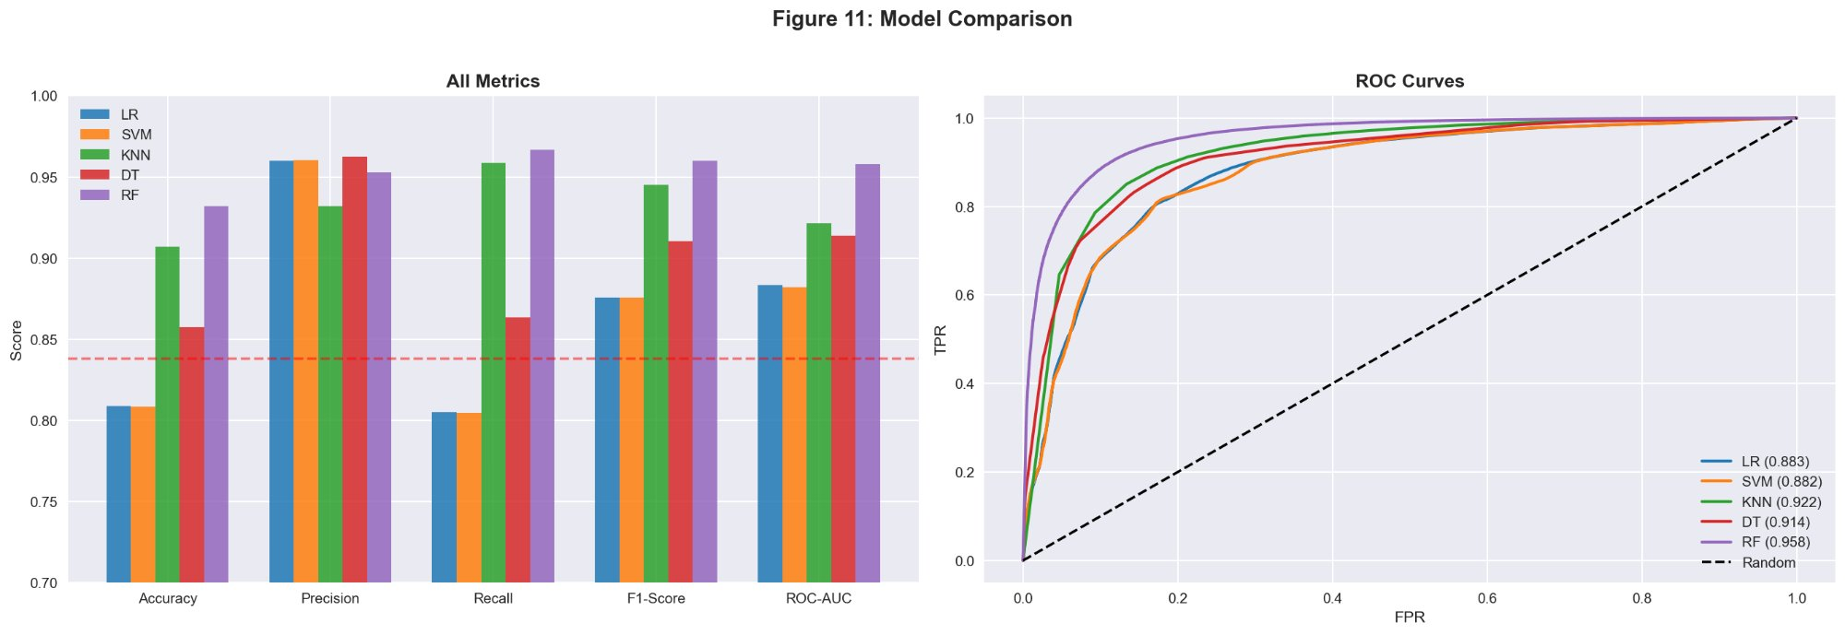
Figure 13: Model comparison — all metrics (left) and ROC curves (right)

5.7 Feature Importance
Longitude is by far the most important feature in the Random Forest model (0.267 importance). Latitude is second (0.168), followed by Owner_Type (0.097), Is_Drought_Season (0.086), and Region (0.085). Geographic features together account for over half of the model's predictive power. Among our engineered features, Is_Drought_Season and Region both made the top 5, which validates the feature engineering work.
The Logistic Regression coefficients tell a complementary story: negative coefficients (blue) are associated with natural fires, positive (red) with human fires. State_Fire_Rate, Owner_Type, and latitude all push toward human-caused predictions. Is_Drought_Season and Region push toward natural. The strong geographic and seasonal signals confirm what EDA showed.
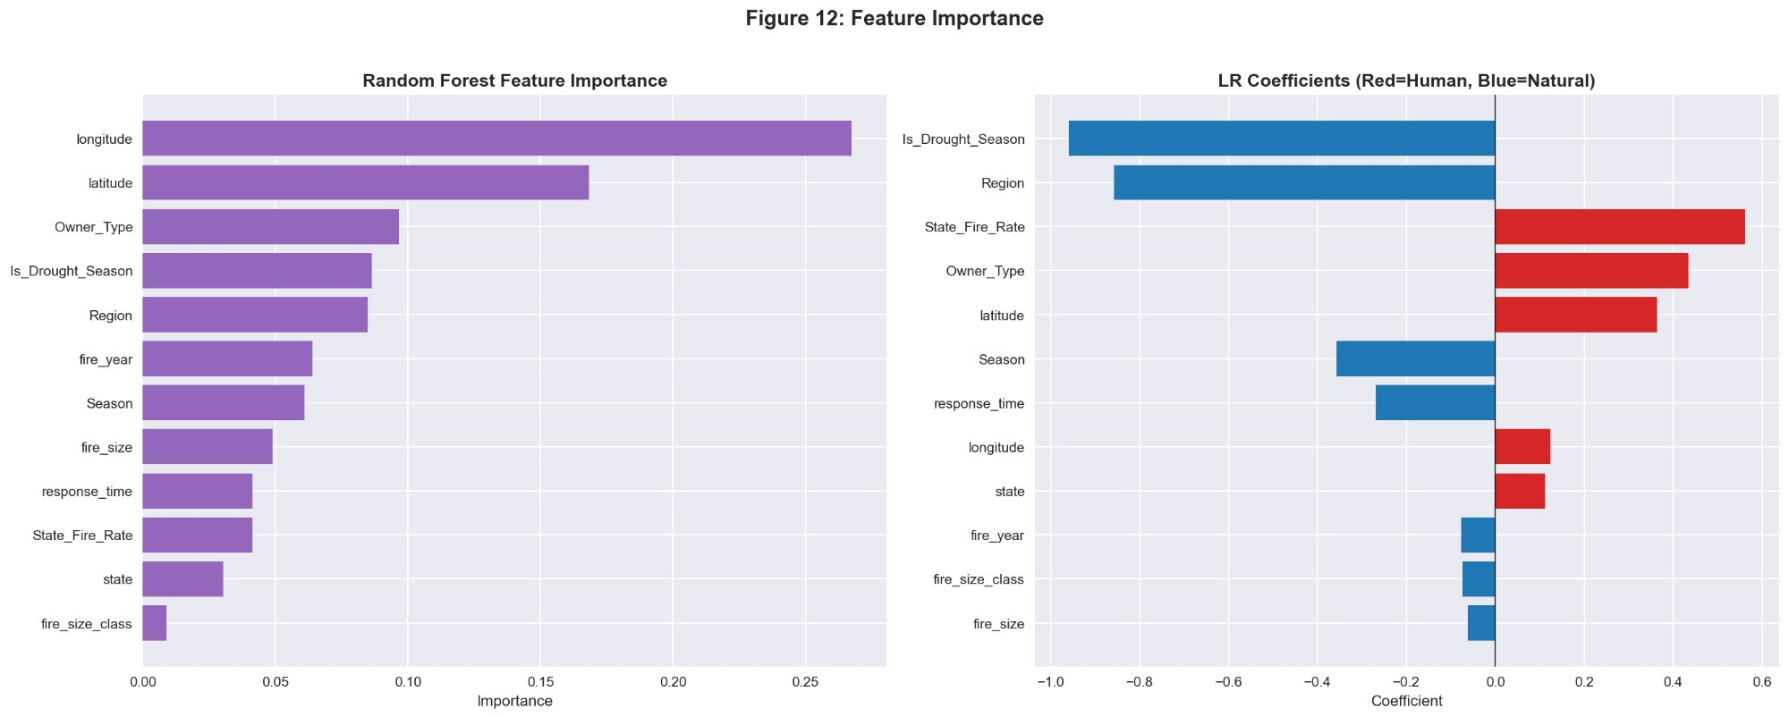
Figure 14: Random Forest feature importance (left) and LR coefficients (right)

6. Conclusion
We trained five models on the full 1.88 million record US wildfire database to predict whether each fire was human caused or natural. Decision Tree and Random Forest count as one model per course rules, giving us 4 model slots: Logistic Regression, SVM, KNN, and Decision Tree/Random Forest.
Random Forest was the best model with F1 of 0.9598 and ROC AUC of 0.9579 after GridSearchCV tuning. It beat the linear models (LR, SVM) by a wide margin because wildfire causes depend on non-linear geographic and seasonal patterns that tree-based ensembles handle well. Cross-validation confirmed the model is stable (mean CV F1 = 0.9590, std = 0.0003).

Main findings:
- Longitude is the single strongest predictor. Eastern states have mostly human fires, western states have more lightning fires.
- Geographic features (longitude, latitude, state, region) account for over half of RF feature importance.
- Our engineered features (Is_Drought_Season, Season, Region) were in the top 5 most important, so the feature engineering paid off.
- LR and SVM both plateau around F1 = 0.876. Linear decision boundaries are not enough for this data.
- The 5.2:1 class imbalance made class_weight='balanced' and F1/AUC metrics important throughout.
- GridSearchCV tuning improved Random Forest F1 from 0.9597 to 0.9598 (+0.0001).

6.1 Limitations
This version of the dataset has no weather data (temperature, humidity, wind). The enriched 55K subset had those features but was too small for the project requirements.
KNN was trained on a 100K stratified sample instead of the full dataset due to computational cost — KNN at 1.37M rows is impractical at prediction time.
Data only covers 1992 to 2015 and may not reflect post-2020 wildfire patterns driven by climate change.
"Miscellaneous" causes were classified as human, which may introduce some noise since the actual cause is unspecified.

6.2 Future Work
Incorporate real-time weather data from NOAA or OpenWeather API to add temperature, humidity, and wind features. Try gradient boosting models (XGBoost, LightGBM) for potentially higher accuracy. Build a multi-class classifier to predict the specific cause (arson, campfire, lightning, etc) instead of just binary. Deploy as a real-time prediction API using fire weather data feeds.

7. References
1. Short, K.C. (2017). Spatial wildfire occurrence data for the United States, 1992-2015 [FPA_FOD_20170508]. USDA Forest Service. https://www.kaggle.com/datasets/rtatman/188-million-us-wildfires
2. Pedregosa, F., et al. (2011). Scikit-learn: Machine Learning in Python. Journal of Machine Learning Research, 12, 2825-2830.
3. Breiman, L. (2001). Random Forests. Machine Learning, 45(1), 5-32.
4. Cover, T., Hart, P. (1967). Nearest neighbor pattern classification. IEEE Transactions on Information Theory, 13(1), 21-27.
5. McKinney, W. (2010). Data Structures for Statistical Computing in Python. Proceedings of the 9th Python in Science Conference.
6. Hunter, J.D. (2007). Matplotlib: A 2D Graphics Environment. Computing in Science & Engineering, 9(3), 90-95.
7. Waskom, M. (2021). Seaborn: Statistical Data Visualization. Journal of Open Source Software, 6(60), 3021.

Appendix: Key Code Snippets
Full code is in the submitted WILDFIRE_V2.ipynb. These snippets show the key steps.

A.1 Data Cleaning
df = df[df['STAT_CAUSE_DESCR'] != 'Missing/Undefined'].copy()
df['DISCOVERY_DATE'] = pd.to_datetime(df['DISCOVERY_DATE'], origin='julian', unit='D')
df['response_time'] = (df['CONT_DATE_DT'] - df['DISCOVERY_DATE']).dt.days
df['response_time'] = df['response_time'].fillna(df['response_time'].median()).clip(lower=0)

A.2 Feature Engineering
season_map = {'Dec':'Winter','Jan':'Winter','Feb':'Winter',
'Mar':'Spring','Apr':'Spring','May':'Spring',
'Jun':'Summer','Jul':'Summer','Aug':'Summer',
'Sep':'Fall','Oct':'Fall','Nov':'Fall'}
df['Season'] = df['discovery_month'].map(season_map)
df['Is_Drought_Season'] = df['Season'].apply(lambda x: 1 if x in ['Summer','Fall'] else 0)
df['Region'] = df['longitude'].apply(lambda x: 'West' if x<-100 else ('Central' if x<-85 else 'East'))

A.3 Train/Test Split and Scaling
X_train, X_test, y_train, y_test = train_test_split(
X, y, test_size=0.2, random_state=42, stratify=y)
scaler = StandardScaler()
X_train_scaled = scaler.fit_transform(X_train) # fit on train only
X_test_scaled = scaler.transform(X_test) # prevents data leakage

A.4 GridSearchCV Tuning
param_grid = {'n_estimators': [50,100,200],
'max_depth': [10,20,30],
'min_samples_leaf': [1,10,50]}
grid_search = GridSearchCV(RandomForestClassifier(class_weight='balanced',
random_state=42, n_jobs=-1),
param_grid, cv=3, scoring='f1', n_jobs=-1)
grid_search.fit(X_train_scaled, y_train)
# Best: n_estimators=200, max_depth=30, min_samples_leaf=1, CV F1=0.9585

A.5 Cross-Validation
cv = StratifiedKFold(n_splits=5, shuffle=True, random_state=42)
cv_scores = cross_val_score(rf, X_train_scaled, y_train, cv=cv, scoring='f1')
# CV F1: [0.9585, 0.9590, 0.9592, 0.9591, 0.9590]
# Mean: 0.9590 | Std: 0.0003 -> model is stable

